Manual execution short graph

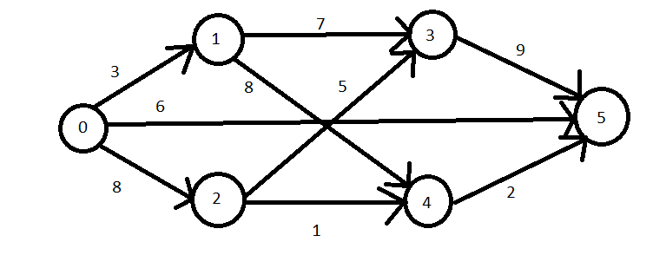

Input file:
6 9
0 1 3
0 2 8
0 5 6
1 3 7
1 4 8
2 3 5
2 4 1
3 5 9
4 5 2

Topological sort:
Iteration | Predecessor count | Queue | Sorted
Initialization | 0 1 2 3 4 5 | [0] | []
Initialization | 0 1 1 2 2 3 | [0] | []
1 | 0 1 2 3 4 5 | [1,2] | [0]
1 | 0 0 0 2 2 2 | [1,2] | [0]
2 | 0 1 2 3 4 5 | [3,4] | [0,1]
2 | 0 0 0 1 1 2 | [3,4] | [0,1]
3 | 0 1 2 3 4 5 | [4] | [0,1,2]
3 | 0 0 0 0 0 2 | [4] | [0,1,2]
4 | 0 1 2 3 4 5 | [5] | [0,1,2,3]
4 | 0 0 0 0 0 1 | [5] | [0,1,2,3]
5 | 0 1 2 3 4 5 | [] | [0,1,2,3,4]
5 | 0 0 0 0 0 0 | [] | [0,1,2,3,4]
6 | 0 1 2 3 4 5 | [] | [0,1,2,3,4,5]
6 | 0 0 0 0 0 0 | [] | [0,1,2,3,4,5]

Topological variants:
-[0,1,2,3,4,5]
-[0,1,2,4,3,5]
-[0,2,1,3,4,5]
-[0,2,1,4,3,5]

Longest path:
-0->5:
[0,2,3,5] - 22
-0->4:
[0,1,4] - 11

